Backorder Prediction

Wireframe Document

By: Akshay Kumar BM

Email: [akshaykumarbedre.bm@gmail.com](mailto:akshaykumarbedre.bm@gmail.com)

Home page:

Enter field:

* National Inventory:
* Lead Time:
* In-Transit Quantity:
* Forecast For 3 Months:
* Sales For 1 Month:
* Minimum Stock Level:
* Performance For 6 Months Average:

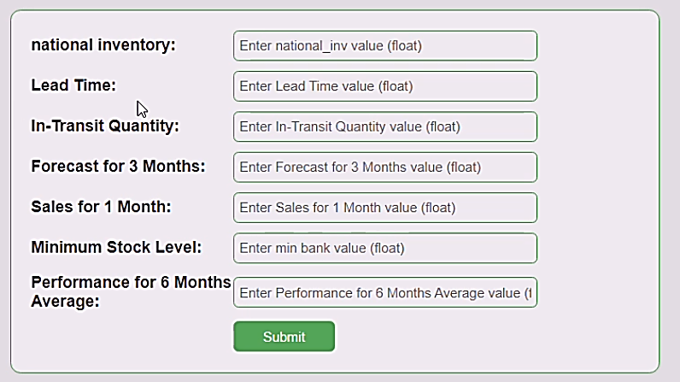

EX

Case 1:

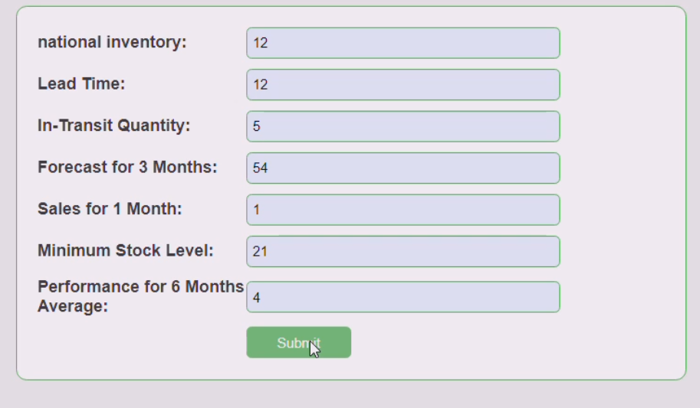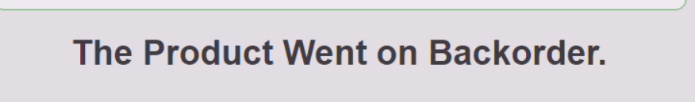

Case 2:

